Embassy of the Republic of South Korea
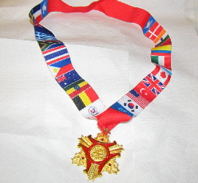

Korean Ambassador for Peace Medal

If you served, you may be eligible for the Korean Ambassador for Peace Medal. The medal is an expression of appreciation from the South Korean government to US service men and women who served in the Korean conflict.
To be eligible, the veterans must have served in country during the Korean War from June 25, 1950 to July 27, 1953. It is also available for the veterans who have participated in UN peacekeeping operations until the end of 1955.
If a veteran was a Navy service member and had served aboard a naval vessel, then he or she is eligible if the naval vessel was assigned into Korean waters during the 1950 to 1953 time frame. You can find this information in the Veteran's Certificate of Release or Discharge from Active Duty, DD 214.
Please note that both men and women are eligible for this medal. The military had support positions such as nurses, clerical and administrative, and other positions that were predominantly held by women service members.
Criteria:
1. The Korean Ambassador for Peace Medal may be awarded posthumously. The next of kin, such as the spouse or descendants, may receive the Korean Ambassador for Peace Medal on behalf of a deceased Veteran. However, please understand that the highest priority for presenting the medal is given to veterans who are currently surviving. The next of kin, such as the spouse or descendants may apply for the medal on behalf of a deceased veteran.
2. To establish eligibility, you need a copy of the Veteran's Certificate of Release or Discharge from Active Duty, DD 214. The DD 214 need not be certified or notarized, but it should be legible.
3. Lastly, there are no costs or fees to the family or to the veteran. There are no legal agreements that need to be met, nor any documents to be signed. This is an appreciation in the form of the Korean Ambassador for Peace Medal from the Republic of South Korea for the sacrifices, service and friendship of our American service men and women who served in the Korean War.

